**EFM CPE Management**Objective:   
  
All CPE can be reachable to get useful information which is necessary for the problems troubleshooting.

EFM CPE Management configuration on DSLAM:  
  
A-Ethernet DSLAM  
  
B-Zyxel DSLAM   
  
  
A- How to configure EFM CPE management on Ethernet DSLAM  
  
1- get EFM Management VLAN of DSLAM from PE or Pedigree  
  
Example:  
  
pe1.nasr2.ca.vxr#sh run int Gi0/3.81

interface GigabitEthernet0/3.81

description Nasr2-Ethernet EFM MNGMT

encapsulation dot1Q 81---

ip address 10.240.13.1 255.255.255.0

no cdp enable  
  
2-create this EFM management VLAN on DSLAM if it is not exists  
  
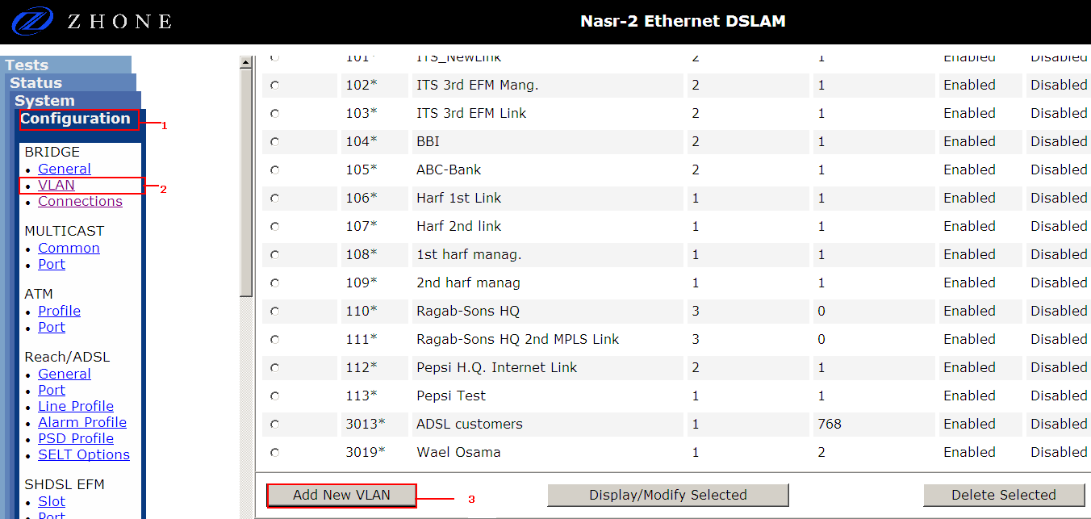  
  
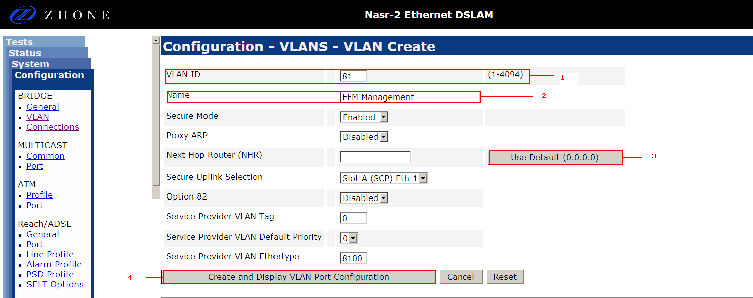  
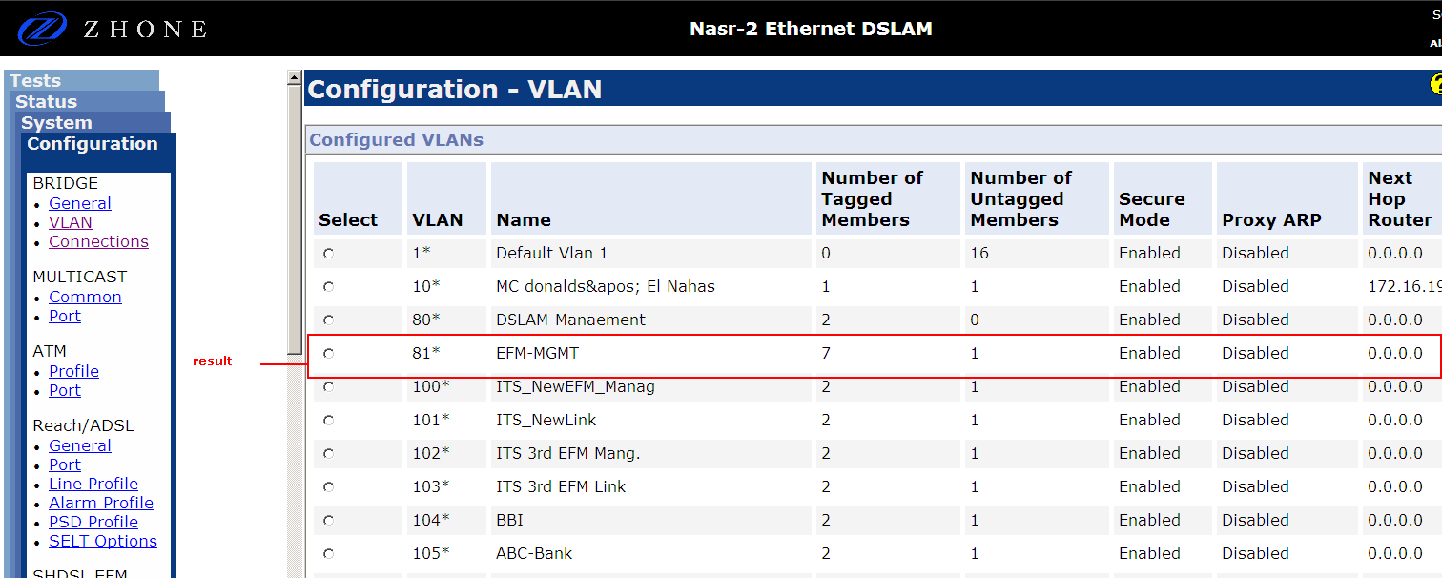

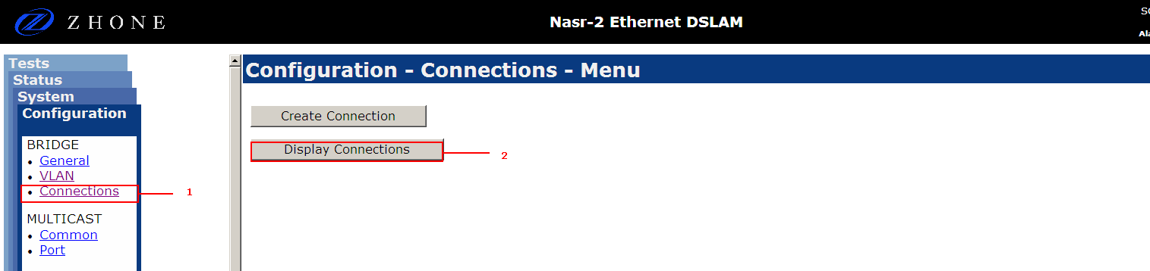  
3- Add Management VLAN to customer data PVC

Select SHDSL EFM card which customer is connected to :  
  
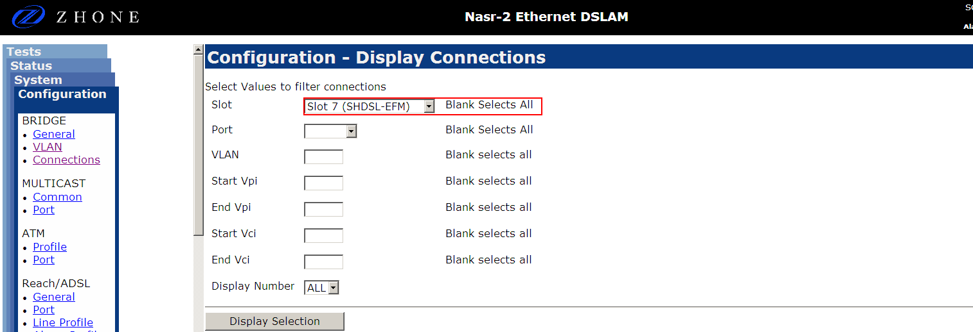

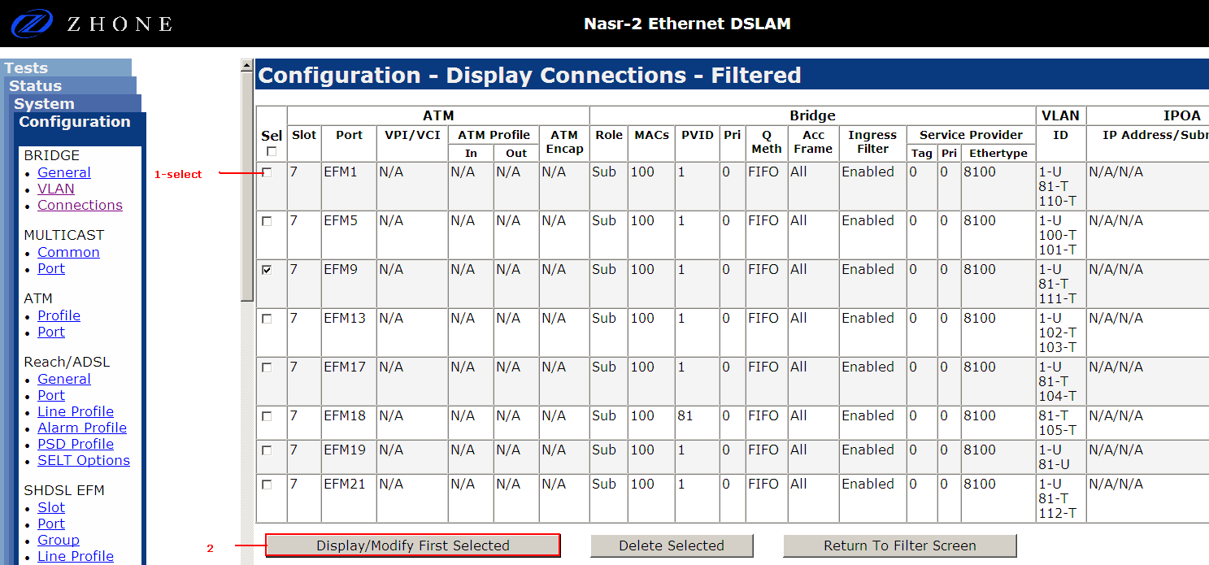

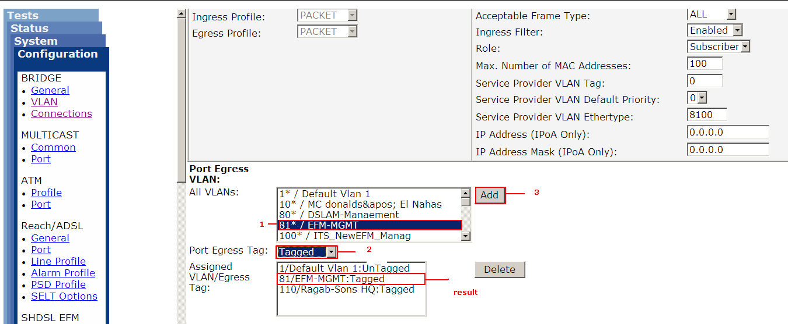  
  
4- check that Management VLAN is added and tagged on DSLAM uplink

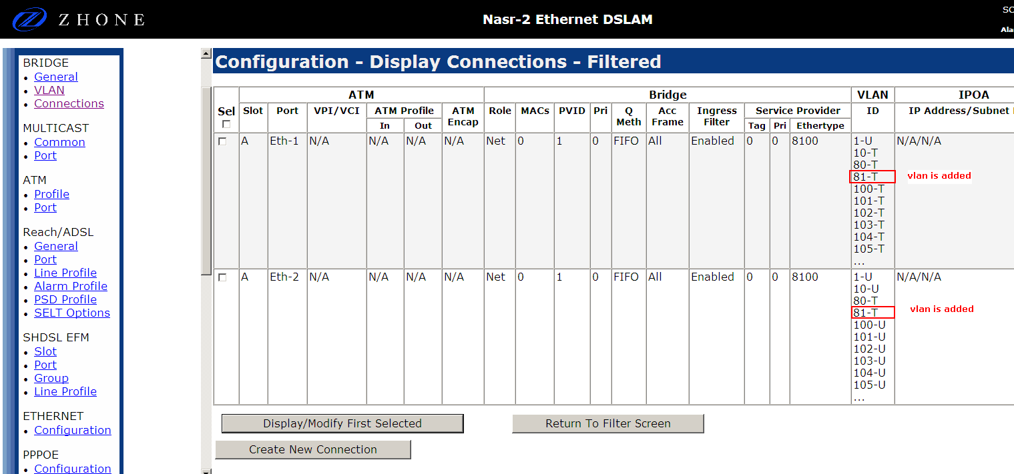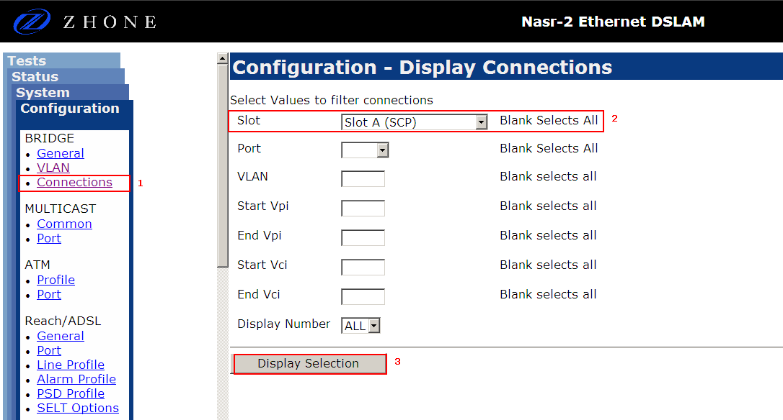

Note : if VLAN is not added nor tagged, so add it as the pervious steps of adding VLAn to customer data PVC

B- How to configure EFM CPE management on Zyxel DSLAM

1- Get EFM Management VLAN of DSLAM from PE or Pedigree  
  
Example:   
  
pe.doki.ca.asr1#sh int des | i EFM CPE

Gi0/0/1.82 up up Dokki Zyxel EFM CPE management  
  
pe.doki.ca.asr1#sh run int Gi0/0/1.82

!

interface GigabitEthernet0/0/1.82

description Dokki Zyxel EFM CPE management

encapsulation dot1Q 82

ip address 10.240.38.1 255.255.255.0  
  
  
  
  
2-create this EFM management VLAN on DSLAM if it is not exists

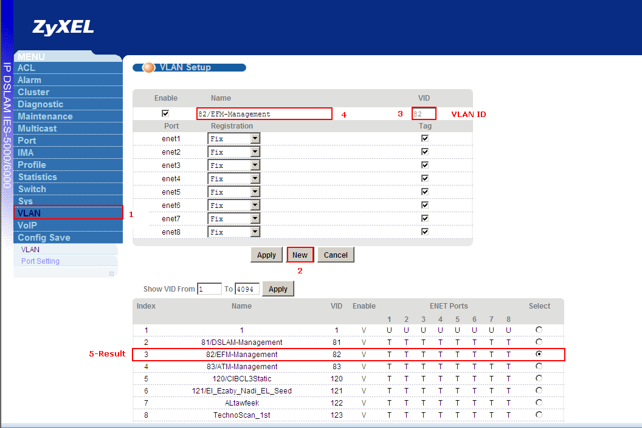

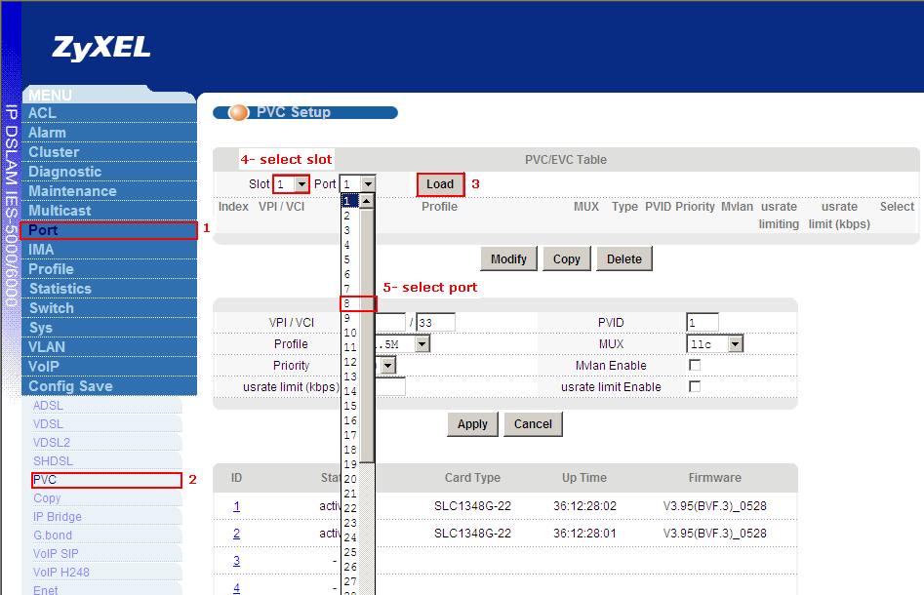3- Add Management VLAN to customer data PVC

Note: for EFM modem, the management vlan will be tagged expect zyxel it will untagged

